
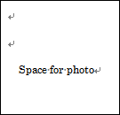
Stamp :

Valid Until :

Letter of Introduction
Family name, first name :

Sex ( M/F ) : Nationality : Age :
Occupation (profession) :
Permanent address :
Phone : Cellphone : Email :
Other Servas travelling with you :
Children travelling with you :
Emergency contact [name, phone, email] :
Languages spoken :
Personal background :

I understand the aims & rules of Servas and will abide by them.
Traveller's Signature:
Coordinator
Name:
Address:
Email:
Date:
Signature:

